roid

217, Sheikh Rashid Building

P.O Box 56272, Dubai

United Arab Emirates

Tel: +971 4 2973236 / 04 2974007

Email: uae@verbat.com

PROJECT   
PROPOSAL

**Responsive Web Site for Coir Directorate**

|  |  |
| --- | --- |
| **Prepared for:**  **Anil Philip** | **Submission Date:**  30 Oct 2017  **Proposal ID:** AD/BP/30102017/1343/1 |

___________________________________________________________________________________________________________________________________________  
Conﬁdentiality Notice: This Proposal is conﬁdential and contains proprietary information and intellectual property of Verbanet Technologies LLC. Neither this proposal nor any of the information contained herein may be reproduced or disclosed under any circumstances without the express written permission of Verbanet.

© 2017 by Verbanet Technologies LLC. All rights reserved. Confidential.

___________________________________________________________________________________________________________________________________________

Project Contacts

|  |  |
| --- | --- |
| Client Information | |
| Project Name | Responsive Web Site for the Coir Directorate |
| Client Name | Coir Directorate |
| Client Address |  |
| Contact Person | Anil Philip |
| Contact Person Email |  |
| Contact Person Phone Number |  |
| Verbat Information | |
| Contact Person | Shibu Kumar |
| Contact Person Phone Number | +971 42973236 |
| Contact Person E-Mail | Shibu.kumar@verbat.com |
| Address |  |
| Physical Address |  |
| Project Information | |
| Proposed Technology/Methodology | Joomla, MySQL, NGINX, GIT, NFS, Jenkins, Maven |
| Anticipate Start Date | NA |
| Proposal Valid For | 30 Calendar days from the submission of the proposal |

**Table of Content**

1 Scope of Work 6

1.1 Solution Objective 7

1.1.1 Home page 7

1.1.2 Main Menu 7

1.1.3 About Us 7

1.1.4 Gallery 8

1.1.5 Contact Us 8

1.1.6 General Pages 8

1.1.7 News 8

1.1.8 Events 9

1.1.9 Downloads 9

1.1.10 Other Important Menu Items 9

1.2 Advantages of Proposed Solution 11

1.3 Why Verbat 11

1.4 Key Differentiators 12

1.5 Technology & Services 13

2 Functional Specification 14

2.1 Site Design & Development 14

3 High Level Solution 17

3.1 Why Joomla 17

3.2 System Architecture 20

3.2.1 The Core 21

3.2.2 The Developer Zone: 22

3.2.3 Continuous Integration Area: 22

3.2.4 Finally, Environments Area: 22

4 Nonfunctional Requirement (Others) 23

5 Assumptions 23

6 Out of Scope 24

7 Technology Solution 25

7.1 Proposed System Environment 25

7.2 Technical Configurations 26

7.2.1 Development Tools 26

7.2.2 Recommended (minimum) Web Hosting Package 26

7.2.3 Browser Compatibility 26

7.2.4 Hardware Interface 26

8 Commercials 27

8.1 Web Application 27

8.2 Payment Terms 27

8.3 Mode of Payment 27

9 Delivery Management 28

9.1 Project Management 28

9.2 Roles and Responsibilities 28

9.3 Delivery Activity Summary 29

9.4 Project Implementation Plan 29

9.5 Deliverables 29

9.6 Estimated Delivery Time 30

9.7 Deliverables 30

9.8 Release Planning 30

9.9 Risk and Contingency Planning 31

10 Change Management 32

11 Miscellaneous 33

11.1 Acceptance Criteria 33

11.2 General Terms and Conditions 33

11.3 Assumptions and Dependencies 34

11.4 Source Code & Intellectual Property Rights 35

11.5 Maintenance & Support 35

11.6 Service Level Agreement 36

12 Our Clients 37

# Scope of Work

The scope of the project is to build a new website for the Directorate of Coir Development (Coir Department), Government of Kerala. The Directorate of Coir Development (DCD) is the implementing agency for all policy decisions of the Kerala Government related to Coir Industry.  Finance Minister, Dr Thomas Isaac holds the additional portfolio of Coir Department. Directorate of Coir Development acts as a facilitator for the promotion and sustainability of Coir sector in the State of Kerala.

The proposed work involves designing and developing a brand new responsive website incorporating all the latest features that would showcase the Directorate and its activities spread across the State. The existing content of the website (http://www.coir.kerala.gov.in) also needs to be migrated to the new website after proper updation and validation. The website would be bilingual – English, as the primary language and Malayalam, as the secondary language.

The website should link all the 10 project offices under the Directorate and the six allied institutions. The website should have details about all the coir cooperatives and information about exporters (exporters’ database) and manufacturers of coir products. There should be provision to upload all Circulars, Government Orders, Tenders, etc. The website would also be a repository of the various forms used by the Department.

The website should be a comprehensive portal that covers the entire gamut of the coir and natural fibre sector in Kerala (Something similar to the Coir Board website in terms of the content.)

Verbat is pleased to submit the proposal and values it as a great opportunity to have a long term & mutually beneficial association with the client. Verbat has gone through the requirement and presents a proposal for the requested system.

**Stand-Alone Fixed Bid**

Verbat will be following a stand–alone fixed bid solution delivery model wherein the required solution would be devised and a suitable pricing would be offered.

## Solution Objective

A legend of the website that will be developed by verbat will be identified below

### Home page

The home page as well as all other pages will have the following characteristics

* Bilingual tab or button to display the page in either English or Malayalam
* Intelligent PDF button that will create a PDF version of the page. The PDF version of the page will vary depending upon
  + If a PDF version of the page is stored separately with a format other than what is on the displayed page, then this version will be retrieved
  + If there is no PDF document available, then a version of the page will be rendered
* Print button, to print a copy of the page displayed
* Email button to email a copy of the page

### Main Menu

* The main menu of the application shall be fixed
* Administrators shall be able to create sub menus under the main menu

### About Us

The About Us section will have several additional sections which will discuss about the different aspects of the Coir Board.

* Vision & Mission
* Organizational Structure
* About Coir
  + Fiber Extraction
  + Ratt Spinning
  + Hand Spinning
* Vital Statistics

### Gallery

The gallery will consist of Video and Image galleries. Folders can be created within the gallery to store images or videos. Galleries may be refereed in articles, news or other online print media so that it can be displayed in line with the article. The sections within galleries are

* Image Gallery
* Video Gallery

### Contact Us

Contains the following sub sections

* Main Contacts
* Sub-Offices: A list of sub-offices with circle offices reporting to them
* Contact Form

### General Pages

These are pages that provide information on the site such as its policies, terms and conditions (T&C) etc.

* Sitemap
* T & C
* Privacy Policy
* Useful links

### News

News will be displayed on the home page. Banner images or a boxed section of the homepage will contain headings of the latest news articles. On clicking the news clip, a detailed page will be displayed

* News article header on home page
* Several news articles with the news section
* Detailed page with news and images
* Admin area to create news items
* An editor or publisher will create news items
* Admin shall be able to set the number of news items that may be displayed on the home page
* The template for the News articles shall be designed and developed during application development

### Events

* Events are similar to news, but they are calendar events that have been scheduled ahead of time and are likely to repeat on regular basis.
* Events shall be associated with a calendar date and time
* Events will be displayed on the home page
* Events will be displayed based on the immediacy of the event
* Admin shall be able to set the number of events that may be displayed on the home page
* Events are created by a publisher or editor
* The template for the events shall be designed and developed during application development

### Downloads

This is a menu item that contains the following links

* Circulars
* Government Orders
* Forms and applications
* Important Orders

### Other Important Menu Items

* Project Offices: A filtered list of affiliated project offices
* Allied Institutions: Description with image and links to other institutions
* Co-Operatives: Tabular data with information on address, registration and society type
* Exporters: A filtered list of exporters
* Manufacturers: Filtered list of Coir product manufacturers
* Products: A filtered list of products that are governed by the coir board
* Marketing : Marketing activities conducted by the board
* Citizen’s charter: Description of the vision, mission and responsibilities of the coir board to the general public

Verbat’s Solution architects have conducted a thorough research on the requirements and have come to the conclusion that our proposed solution, which is detailed further in this document, will meet the requirements put forth by the client. And the proposed solution will be delivered in a phased approach as per Verbat’s stand-alone fixed bid solution model.

**Strong and Scalable platform:** The platform proposed will be strong and scalable enough to accommodate future enhancements.

**Accelerated solution:** The framework would act as a solution accelerator. It would provide the basic building blocks which could be reused in future for building new components and features.

**High performance:** The light weight framework used consumes fewer system resources thereby making the application perform faster.

**Security:** The application will be developed considering various aspects of security.

## Advantages of Proposed Solution



01

Agile development offering reliable, secure solution

02

Smooth transition and quicker completion of processes

03

User friendly interfaces enabling easy navigation between screens

## Why Verbat

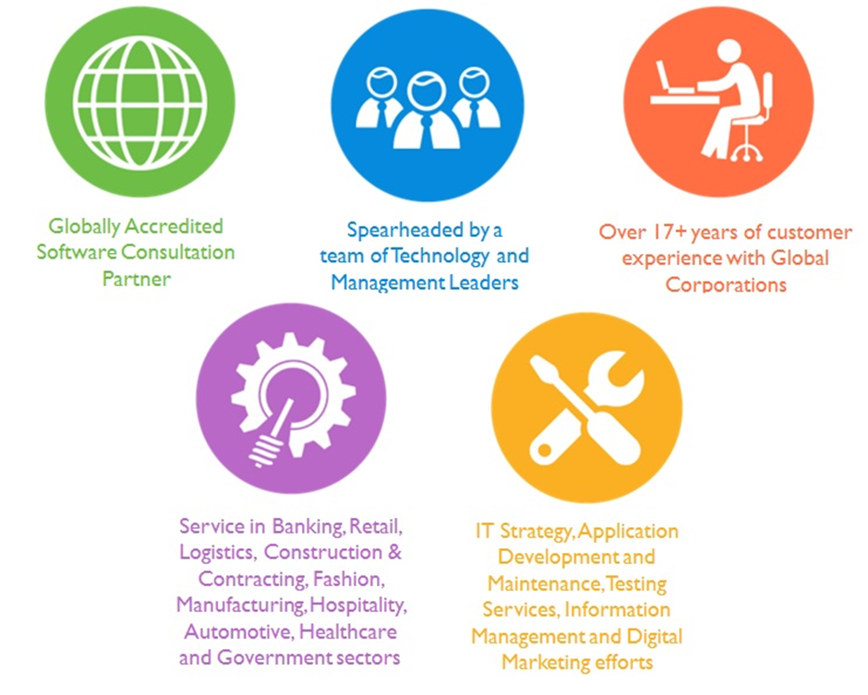

## Key Differentiators

Delivered digital transformation expertise to global customers for over a decade by following industry best practices to maximize ROI for client

Keen technology intelligence combined with aggressive market research to deliver solutions that achieve results with measurable value

Enable access to global consulting expertise with strong local market and business knowledge

Commercial Model that is customizable for your business needs

Services that are designed to optimize applications for improved performance and overall efficiency

1,000,000 plus man-hours of expertise in technology frameworks spanning Microsoft, Open Source, mobility platforms and other proprietary IT technology

Partners top technology vendors to bring in the latest and best services in integration, collaboration, and development

Commercial Model that is customizable for your business needs

Proven Methodologies & Processes

Investment in R & D

Strong Local Presence

Flexible commercial Models

Technology Associations

Software Development Experience

Offshore Development Centre

Quality Assurance & Testing

## Technology & Services

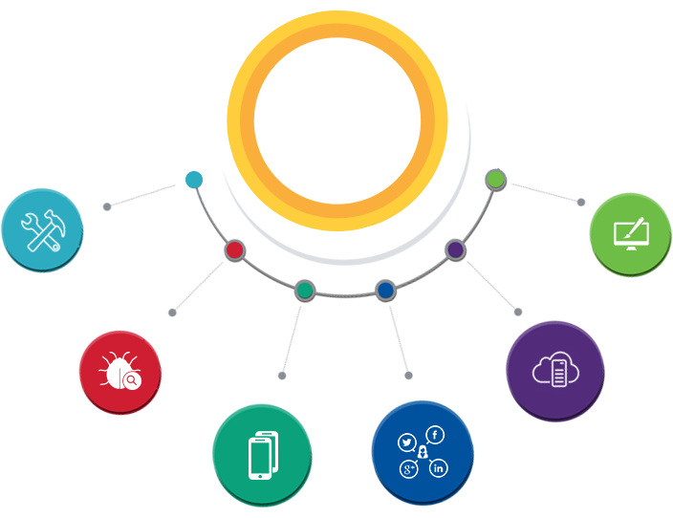

Technology  
&  
Services

Cloud/Traditional Hosting

User Interface & Design

Digital Marketing

Mobility Solutions

Testing Services

Application  
Development

# Functional Specification

## Site Design & Development

|  |
| --- |
| Home page with sections (news, Events, Gallery) |
| **Common page features** |
| Language selector |
| Email current page |
| PDF of current page |
| Print current page |
| Search By |
| Documents |
| Site content |
| **Footer pages and links** |
| Site Map |
| Privacy Policy |
| T&C |
| Copyright |
| Usefull Links |
| Archives |
| **Contact US** |
| Feedback |
| Sub Offices ( added via backend using DB) Below offices are replicated using templates |
| Chirayinkeezhu |
| Kollam |
| Alapuzha |
| North Parur |
| Ponnani |
| Kannur |
| Kayamkilam |
| Thrisur |
| Kozhikode |
| Vaikom |
| **About US** |
| Vision n mission |
| Org Structure |
| About Coir |
| Fibre Extraction |
| Ratt Spinning |
| Hand spinning |
| Right to Service |
| Right to information |
| Citizens Charter |
| Vital Statistics |
| **Page Templates** |
| News |
| Events |
| Sub Office |
| Gallery |
| Project Offices |
| Allied institutions |
| Coir Co-operatives |
| Exporters |
| Manufacturers |
| **Downloads** |
| Circulars |
| Gov Orders |
| Various forms and applications |
| Tenders |
| Important Orders |
| **Services** |
| Plan Schemes |
| Career |
| Articles |
| Projects |
| **Admin** |
| Login |
| Manage Users |
| Editors |
| Publishers |
| Add Submenu / Menu (optional) |
| Update |
| Add Sub Offices |
| Add news |
| Add events |
| Add gallery |
| Add Project Offices |
| Add Allied institutions |
| Add Coir Co-operatives |
| Add Exporters |
| Add Manufacturers |
| Add Products |
| Upload |
| Circulars |
| Gov Orders |
| Various forms and applications |
| Tenders |
| Important Orders |
| Products |
| Marketing |

# High Level Solution

## Why Joomla

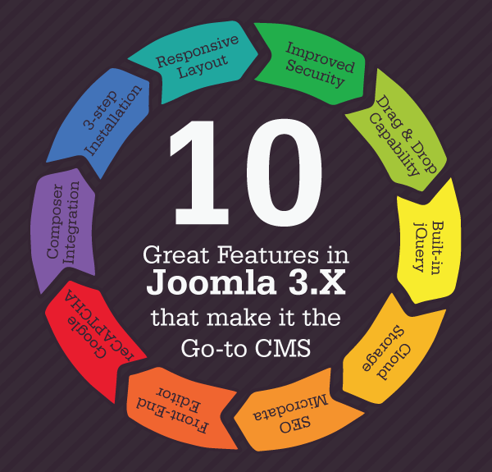

1. **Responsive Layout**

Joomla brings a beautiful a seamless layout that is perfect for any device and any screen. Responsiveness on both the backend (admin console) and frontend are now a reality. With its user-friendly interface you are bound to enjoy using Joomla.

1. **Improved Security**

2-Factor Authentication is now available with Joomla 3.x to fortify your security. Similar to 2-Step Verification in Google, it improves security by only granting access to users once they enter the pin code they receive on their mobile phones/email.

1. **Drag & Drop Capability**

Drag & drop was really the most prominent feature that many web design platforms and applications provided but not always to a great extent. This is where Joomla 3.x is changing the game by allowing users to reorder items quickly and easily.

1. **Built-in jQuery**

‘Write Less, Do More’ has a whole new meaning as jQuery is now a built-in cross platform of Joomla. It’s the most popular JavaScript library that allows you to create rich effects, widgets, themes, and interactions for applications and more.

1. **Cloud Storage**

The all-new cloud storage API enables users to maximize leverage on cloud data subscriptions. This allows users to back up important files in the database and even backup the database based on schedules that you can easily choose.

1. **SEO Microdata**

One of the underrated features in Joomla 3.x is the SEO microdata. Now users can easily improve and optimize the content, pages, posts, and elements on their website with this comprehensive SEO microdata feature and climb the search engine rankings.

1. **Front-End Editor**

Some days when you are in a rush or you have a deadline task to meet that involves the use of your Joomla website, you will be thankful that the 3.x version finally brings frontend editor. Now edit on the frontend intuitively and save time!

1. **Google reCAPTCHA**

Let’s face it; nobody likes to have spam in their comments section and especially registration forms. With Google reCAPTCHA you can now fortify logins and registration forms to protect them against spam and keep your website neat and clean.

1. **Composer Integration**

If you happen to work with external code libraries or if they are a part of your online footprint then Joomla 3.x has a nice surprise for you. With composer integration, you now get to seamlessly integrate code libraries from external sources.

1. **3-step Installation**

Perhaps the best feature about Joomla 3.x is that anyone can install it by following three simple steps. The installation only takes a couple of minutes and once it’s done you will be making use of a powerful CMS with strong core capabilities.

The image above is a conceptualization of the search algorithm described by the client. Keywords are analyzed for etymology, context, geographic information and relevance. The package definitions are applied over the results to derive the final result. Search keyword results are attributed with additional information such as business, map, and context etc. using stylized icons. Search results are interpreted differently for desktop and mobile devices.

## System Architecture

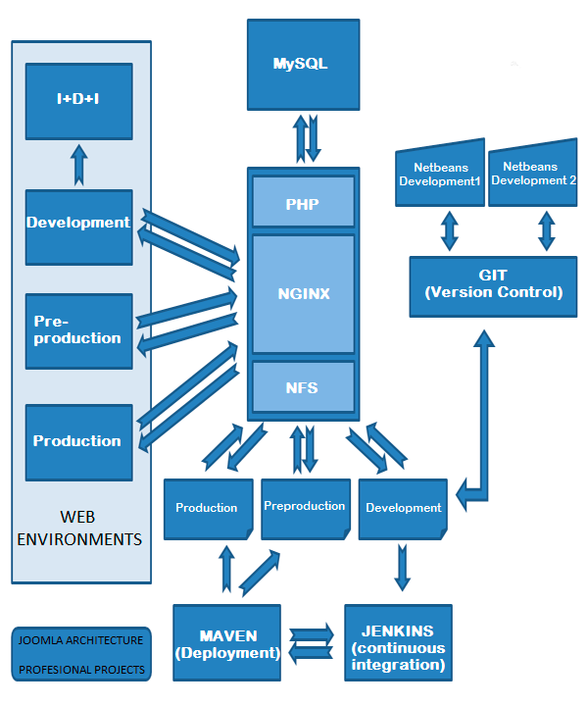

The image above represents the infrastructure and server hardware defined to facilitate the following:

* Version control
* Operational prototyping
* Automated deployments
* Automated unit testing
* Automated testing functions
* Continuous Integration

These moving parts are described in more details below.

### The Core

The heart of the server infrastructure is a web server called Nginx. Nginx can be configured to be a high-availability system, with load balancing, separating the dynamic content from the servers which deliver only static content. So, in addition the system is ready for a steady migration to the cloud. If we need Apache compatibility, we would mount it below the Nginx or in parallel for those tasks where compatibility is essential.

What is also part of the heart is the MySQL server. Or more specifically the farm of servers (If need be) that synchronized between them, when necessary, serves a different environment that displays the customer portal.

A PHP interpreter is responsible for the implementation of the pages which Nginx should serve. With the necessary modules for Joomla to deploy all the power required by the customer, but removing all of those which do not contribute with any added value, which means an increase of charge in the system or the slightest risk in terms of security concerns.

Completing finally this "core", the NFS server responsible for the exchange of files between the rest of the applications that make up the image above. The communication of the "core" with dedicated high-speed lines, facilitate the composition of the page requested by the Internet in the shortest time possible.

### The Developer Zone:

Each developer has an IDE environment where you can find the tools integrated of the version control management, and various utilities that facilitate the development of extensions for Joomla.

All which is centralized in a GIT server that connects to the kernel NFS server to dump the versions validated by each team member.

### Continuous Integration Area:

Configuring a deployment tool and a Continuous Integration Manager responsible for the launches of unit testing (PHPUnit) and functional (Selenium) as well as scheduled deployments between different environments.

In this way we simplify the unit testing phase of development teams in a first integration between different developers and future user tests by automating those functional tests which are mandatory every single time you change a Joomla project.

### Finally, Environments Area:

We have four distinct environments which are isolated from each other. Being Joomla a content management system, there is a particular situation of feedback from the production environment to others.

The integrated development environment (IDE) is used by team to create artifacts as well as integrate the changes into a single repository.

The development environment which constantly changes, due to integration of changes from unit tests as well as changes from other developers in the rest of the team.

The Preproduction (or beta) facilitates that the user will be able to test exactly like you would on the production system but without the risk of stopping it.

All these environments are configured to use different databases, different mail servers, independent backup systems, etc…

# Nonfunctional Requirement (Others)

|  |  |
| --- | --- |
| **Requirement** | **Details** |
| User Experience and  UI Design | * The application will be developed only in English and Arabic * The layout and graphical components will be created considering the usability factors |
| Performance | * Application will allow users to have smooth and quick access to the information or services they require. |
| Security | * The system will be protected against attempts of security breaching that may arise. * Web security standards will be followed. |

# Assumptions

The project solution and technology is created from the initial understanding of the requirement shared with Verbat through mails and meetings. The proposed solution is based on the following assumptions:

* Client to provide Verbat with the branding guidelines.
* The proposed application will be bilingual (English & Malayalam)
* Client will purchase the necessary templates needed for development
* Client shall provide licensed images and logos in specified size & format
* Requirements should be well defined, agreed and signed-off by the client
* Internet connectivity is required for the functioning of the web application.
* Customer will procure SSL certificates
* Testing will be done in latest versions of Google Chrome, Mozilla, Safari, & Edge web browsers only
* Development Contingent upon timely feedback from client

# Out of Scope

Following are considered to be out of scope while creating this proposal.

* Purchase of images, fonts
* Adding new features to the application other than mentioned in the functional specification.
* Any language other than English & Malayalam
* Manual data entry
* Hardware Integrations / procurement and purchase
* Database migration
* Content writing
* Content or image procurement or uploading or editing.
* Hosting Infrastructure and Maintenance
* Annual Maintenance of the application (Bug fixing, debugging) - For AMC details, please refer section titled “Maintenance and Support”
* Physical deployment at client’s site
* Backup solution and Disaster recovery

# Technology Solution

## Proposed System Environment

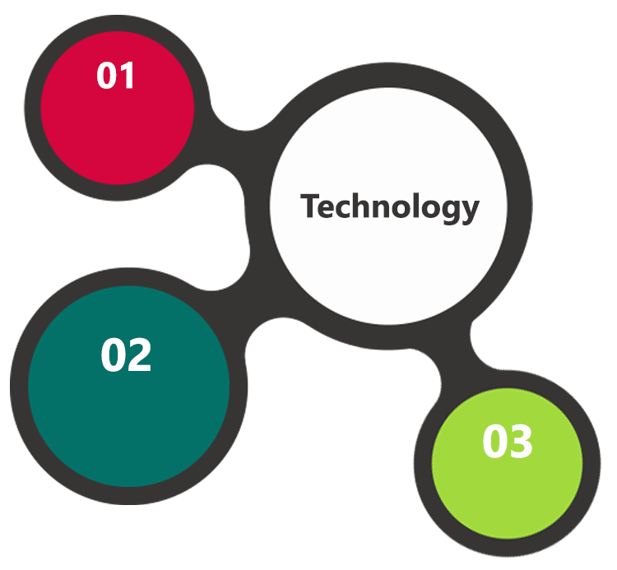

NGINX, MySQL

Joomla, PHP, Apache

HTML / CSS3/ Jquery

**MS SQL2012  
Windows 8/10  
Web Services**

## Technical Configurations

### Development Tools

* Joomla, Netbeans
* PHP, MySQL
* HTML / CSS 3
* Ajax, JavaScript, JQuery

### Recommended (minimum) Web Hosting Package

* OctaCore CPU
* RAM: 32 GB
* Disk Space: 1 TB
* Monthly Bandwidth: 20 TB
* Web site Server Software – Apache

### Browser Compatibility

* Chrome version: 56
* Firefox version: 51
* Edge version: 39
* Safari version 10.1

### Hardware Interface

**Desktop**

The application is reliant on hardware interfaces to provide a seamless automated user experience.

* Computer with Windows 8 or 10 OS
* Compatible Browsers as specified in section 7.2.3

# Commercials

## Web Application

|  |  |  |
| --- | --- | --- |
| **No** | **Description** | **Amount (USD)** |
| 01. |  | 00,000.00 |
| 02. |  | 00,000.00 |
|  |  |  |

## Payment Terms

*Note: Payment should be made within 7 days from the date of the invoice*

## Mode of Payment

By Cheque / DD to Verbanet Technologies LLC

OR

Wire transfer to our bank account

Bank Name : Emirates NBD

Account Name : Verbanet Technologies LLC

Account Number : 1011492858201

IBAN Number : AE61 0260 0010 1149 2858 201

Swift Code : EBILAEAD

Bank Address : Mamzar Branch, Dubai

*Note: Bank charges incurred during wire transfer to be borne by the client. Any local taxes applicable to be borne by the client*

# Delivery Management

## Project Management

The Verbat development center strictly follows industry standards on quality. The project management is process governed by the Verbat Quality Management system and is put to verification through internal audit programs that happen from time to time.

Verbat will dedicate a project manager for the proposed implementation. Verbat proposes Client to identify one project manager who will be driving activities to be undertaken by Client to be the single point of contact for Verbat.

## Roles and Responsibilities

Verbat will assign a dedicated Project Manager/Project Lead to lead the project, who will be the first point contact for Client. He/she will be responsible for planning and managing the various activities within the project. He/she will work closely with Client Project Manager, to give periodic status updates and ensure high level of visibility and comfort on the progress of the project.

The Project Manager/Project Lead will lead the co-ordination between Verbat and Client, thus enabling smooth transitioning of Client requirements to the Verbat’s offshore delivery team, and provide visibility as well as comfort on the progress of the services to Client.

He/she will have periodic meetings with Verbat’s Senior Management, thus ensuring Verbat’s Management commitment and focus on Client initiatives.

## Delivery Activity Summary

|  |  |
| --- | --- |
| Activities | Description |
| Detailed requirement Analysis | Verbat team to conduct detailed study of requirement for the phase. If clarification is required, team will reach out to Client for more information and/or time for discussions. |
| DB Design | DB design for central and test DB. |
| Software Requirement Specification document (SRS) | Once the requirement analysis is completed, Verbat team will submit the SRS document for approval |
| UI/UX Design, Prototyping | Based on the SRS, Verbat UX/UI team will work on the UI/UX of the screens and submit a prototype for approval |
| Functional Specification Document (FS) | Once the Prototype. UI/UX is approved, Verbat shall submit an FS document for approval. |
| Development | Actual system development starts based on the FS. This involves detailed design and software development of Web Application. |
| Testing | Test Planning, test plan creations, internal, integration testing and user acceptance testing. |
| Deployment | Deploying the latest built in the Verbat Test Server. |

## Project Implementation Plan

Verbat will be providing the solution in a stand-alone fixed bid approach which ensures minimum viable solution for quick wins with core focus on the long-term business objective and outcome. Once the implementation is over, Verbat will initiate the application maintenance process (once the maintenance contract is signed) which continues to extend after the implementation.

## Deliverables

* Scope Document
* Project Plan
* Design templates
* Functional Specification Document
* Prototype of the application
* Test Plan Document
* User Manual
* Source Code
* Fully Developed & Tested Application

## Estimated Delivery Time

The effort estimated for delivering the application is as follows;

Update schedule

## Deliverables

Development will be split into 2 phases. Each phase split into 3 sprints each with a concise description of items that will be delivered for each sprint. The deliverables for each sprint will be dictated by the client.

The list below is a brief overview of the items that will be delivered mainly for referral purposes. The actual items delivered will be vary based on the decisions made at the time.

## Release Planning

* Client will be informed about the release date and time through email.
* Client performs the UAT

## Risk and Contingency Planning

Verbat has identified various risk factors associated with this assignment and understands the impact of these risk factors on the project schedules. The objective of this section is to highlight for both Verbat and client, the risk factors, to analyze the impact of the risks on project execution, and to propose strategies to control and reduce the impact of the risk factor.

These various risks, which could arise during the project, are tabulated below along with mitigation implementation.

| Type of risk | Impact | Risk Mitigation | Risk Handling |
| --- | --- | --- | --- |
| Scope Creep | H | Functions and features will be detailed in system requirement documents and will go through client approval. Once this document is approved, any change to requirement will go through change management review for possible impact assessment. | Proper change management procedure will be implemented. |
| Delay in customer feedback | H | The plan is prepared with enough lead-time for customer reviews and approvals.  The customer is indicated with the dates when the document is expected after review and approval. | The request for feedback will be escalated if not attended at the right time so that the schedules are not affected. Deemed acceptance criterion is set up front and will be followed. |
| Non-availability of necessary software’s, frameworks, database instances and infrastructure at client’s hosting environment(If hosting support is provided by Verbat) | M | Client will be informed in advance on these requirements. | Possible impact to schedule. |
| Manpower attrition | L | All efforts would be made to ensure process dependence rather than being person dependent. As a risk mitigation plan Verbat will train backups. | A new person will be identified as early as possible, provided the required project-specific training and mentored by the senior members of the team to minimise impact of attrition on the project. |

*H-High, M-Medium, L-Low, NA-Not Applicable*

# Change Management

Any addition which comes out of the project scope, upon and after the launch of the tool will be considered as change management. Verbat recommends the following change management procedure for the same.

* Any change which comes out of the project scope, which was discussed, documented, and mutually approved by both the parties in the requirement stage, will be carried out only through raising a change request.
* Change request will be studied and an impact analysis on the existing work flow will be performed.
* On finalizing the impact, effort estimation for the change will be calculated and raised as additional requirement.
* Verbat will initiate the change request only after getting a formal approval from the client for the additional changes raised.
* Any change from the scope will be charged at **USD ----- per man day effort** and approval from the clients will be availed before commencing on any change management.

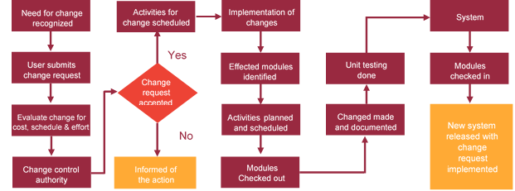

# Miscellaneous

## Acceptance Criteria

* UAT sign off should happen within 14 Days from the release of the application/ Phase and the acceptance confirmation needs to be mailed to Verbat failing which Verbat will consider the project as approved by the client.
* Any comments or reason for rejection need to be documented and the same needs to be sent as an email from the official mail id of client to Verbat.

## General Terms and Conditions

* All the projects activities will be carried out from our off-shore development center in India
* The scope of the project is to develop the Application as detailed in the scope of the project and mentioned in this proposal. Any changes or additions will have to go through change management.
* This proposal and all technical/ functional specifications have been derived or concluded from the data shared via email / information's transferred during the initial requirement analysis meetings and conversations. Verbat reserves the right to amend the terms of this proposal, should the SOW terms, functional features and functionalities change during the course of the project
* Application will be best viewed only in the environment mentioned in this document
* All the documentation will be provided in English.
* Third party components may be used to develop this application.
* All Source Code and other project artefacts would adhere to the Verbat document templates and internal coding standards
* Client shall provide the respective enterprise apple store and Google play store accounts for development and production
* Acceptance criteria shall be based on the clauses which were mutually discussed between Verbat and client at the Requirement Analysis phase and the same will be documented and approved by both parties through official emails
* In case Client requires any extension of the proposed acceptance schedule, the associated effort and cost of such extension can be mutually reviewed.
* For any circumstances if project needs to be put on Hold / Stop it requires minimum request notice period of 2 weeks along with duration for which request will be addressed by management and final decision on the request will be based on that
* If deployment is done in client’s server, Verbat cannot be held responsible for any performance issues arising due to hardware malfunctions.
* Source code will only be delivered or uploaded on the Production Server once the due payments are made.

## Assumptions and Dependencies

* Detailed system study is required before the start of the project.
* During the requirement gathering phase, authorized personnel from the Client’s side is expected to be available for discussion and finalizing the HLD (High Level Design), before development commences.
* Type of reports and formats, if under the scope of the project, needs to be specified by Client before project sign off.
* Workflows if under the scope of the project, need to be specified/ confirmed by client before project signoff.
* All queries regarding the client requirement and any queries which may hinder the project advancement at any stage should be answered by the client within 24 hours from the time of initiation, failing which the time delay will get added to the actual effort which was estimated.
* Verbat assumes that all sign-offs from Client will be provided within agreed and specified timeframe.
* Client will provide all the necessary contents, both text and image, before starting the project in the format suggested by Verbat (if any).
* The client should provide the relevant information and data well in time for the execution of a related activity. Non- availability of this information or data may lead to an interruption of work which may result in a delay in delivery as well as additional costs to the client.

## Source Code & Intellectual Property Rights

* Upon completion of the Project and 100% completion of the payment, client will have access to the source code except for propriety codes, developer tools and third party application etc.
* The solution offered will be the intellectual property of the client and will be made available to the client on an “unlimited license” basis.
* Modifications by third party/person: No person or organization, other than Verbat or any person authorized by Verbat in writing, has any permission to modify/change the software Solution to be eligible to get continued support from Verbat as per the support terms defined under this document.
* Liabilities/Damages: Verbat accepts no liability or damages of any kind arising out of use or non-use of the software delivered. The responsibility of testing of software lies with Client.

## Maintenance & Support

* Maintenance contracts by default are supported as per the basic SLA terms.
* **AMC with Basic SLA is charged at 20 % of the total project value**. Additional Effort/change management request will be added towards Total Value of the Project to determine the AMC value.
* Maintenance support is limited to providing application support for ensuring the consistency of the look-and-feel, bug fixes and user issues i.e. maintenance and support of the existing features of the application.
* Support does not in any way cover providing technical or other support to the end users. The maintenance agreement does not include functionality changes or feature additions which are handled as change requests which will be charged AED 1200 per man day. AMC does not include server support, maintenance and application deployment.
* AMC charges will cover Off-Site Support and Debugging. Support includes E-mail, Telephone and Chat unless explicitly specified. In the event, the application is hosted with the client; necessary remote desktop connectivity should be provided for carrying out maintenance activity.
* Gap in AMC - In case if the client does not opt an AMC for a year and want to renew it after that period, 50% of the AMC amount for the year for which AMC is not taken will also be payable if the client wishes to renew the AMC contract.
* Note:
  + Please note that the AMC support shall start only after all the necessary sign-offs (AMC Document) to this effect have been given.
  + It is not mandatory that the client should opt for an AMC. The client will still be supported on an ad-hoc basis on an agreed man-day rate.
  + AMC Payment Terms: 100% to be paid as advance.

## Service Level Agreement

|  |  |  |  |  |
| --- | --- | --- | --- | --- |
| **Key** | **Max Response Time** | | **Max Resolution Time** | **Target** |
| Basic | 1  working day | 3 working days | | Request / incident / problem tickets |
| Advanced | 5 Business Hours | 12 Business Hours | | Request / incident / problem tickets |
| Priority | 3 Business Hours | 5 Business Hours | | Request / incident / problem tickets |

Note:-

* We provide Basic SLA as standard with AMC while Advanced and Priority SLAs attract additional charges.
* Time zone applicable as per India time zones (3:30 AM GMT to 12:30 PM GMT- Monday to Friday).

# Our Clients

**UAE University**

Education

Transportation

**Canada Cartage**

Construction

Services

Finance

We look forward to hearing from you soon and hope that you will give us the privilege to work with you in meeting your business goals. Thank you.

Thank You



©   
1999 - 2017. All Rights Reserved   
Verbanet Technologies LLC  
www.verbat.com